Project 15-2: Managing Risk Through Copying Data—Journaling
Estimated Time: 25 minutes
Objective: Copy user data to the cloud using journaling.
Description: While a scheduled event backup is important, even more important is having the flexibility to copy data between these scheduled events. This provides the best of all worlds: a backup can be scheduled to run daily at a specific time, but users can also designate specific data for immediate copying. In addition, software can monitor what files have changed and then automatically update the copies of the files with the most recent versions (replication). In this project, you explore these two additional data copy solutions using iDrive.
- Another means of backing up files is to select files or folders to be copied immediately to iDrive. Click Cloud Drive in the left pane.
- Click Enable Sync.
- Open File Explorer on your computer.
- Note that there is now a WDAGUtilityAccount folder. Open this folder.
- Open the Cloud-Drive folder.
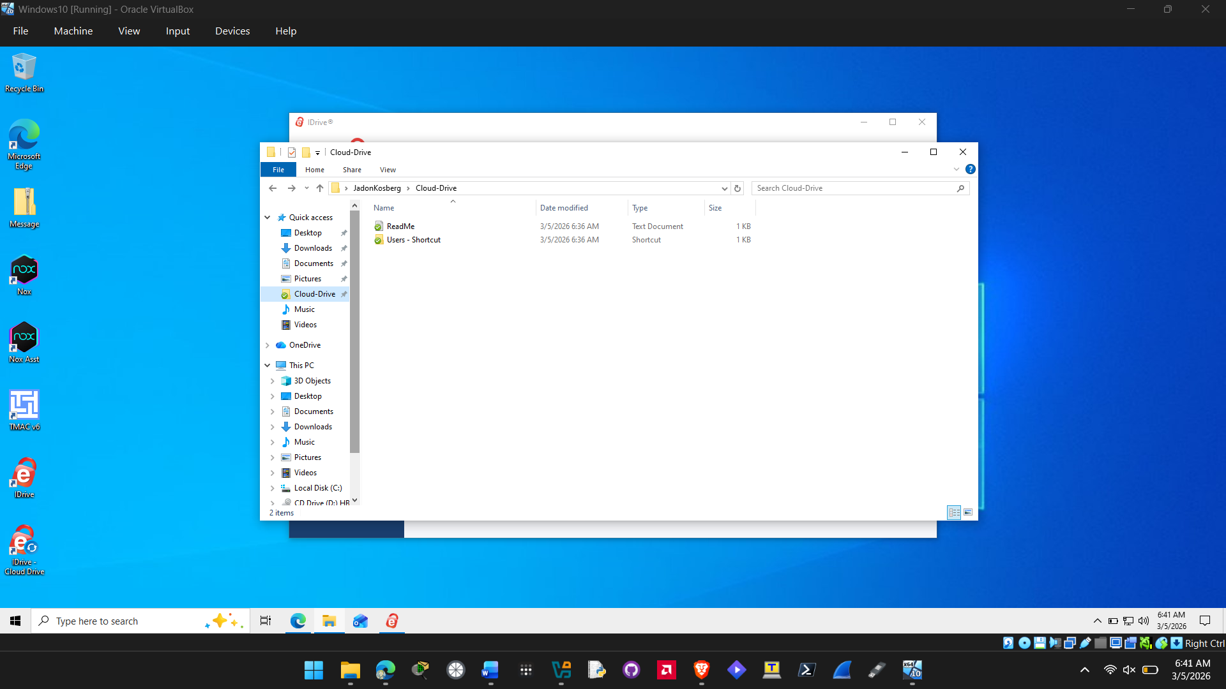

- Read the ReadMe file.
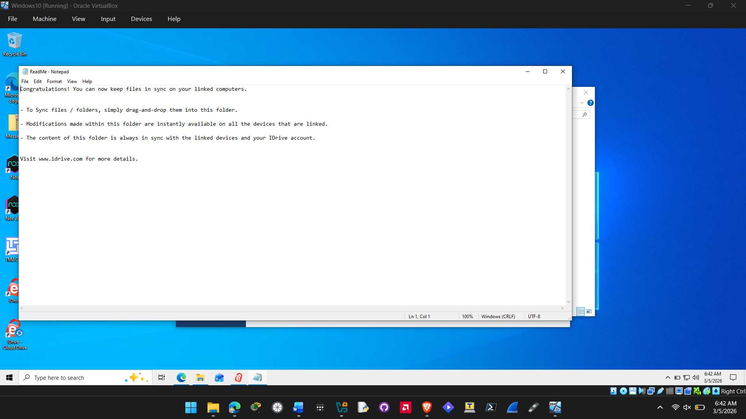
- Any file or folder that is dragged into the Cloud-Drive folder is immediately copied to iDrive. Select a file or folder and drag it into the Cloud-Drive folder.
- A final means of copying data is to have any file that is changed to be immediately copied to iDrive. Create a folder named Test in one of the folders that you have previously selected to be copied to iDrive.
- Create a document using Microsoft Word that contains your name and save the file as Replicate1.docx in that folder.
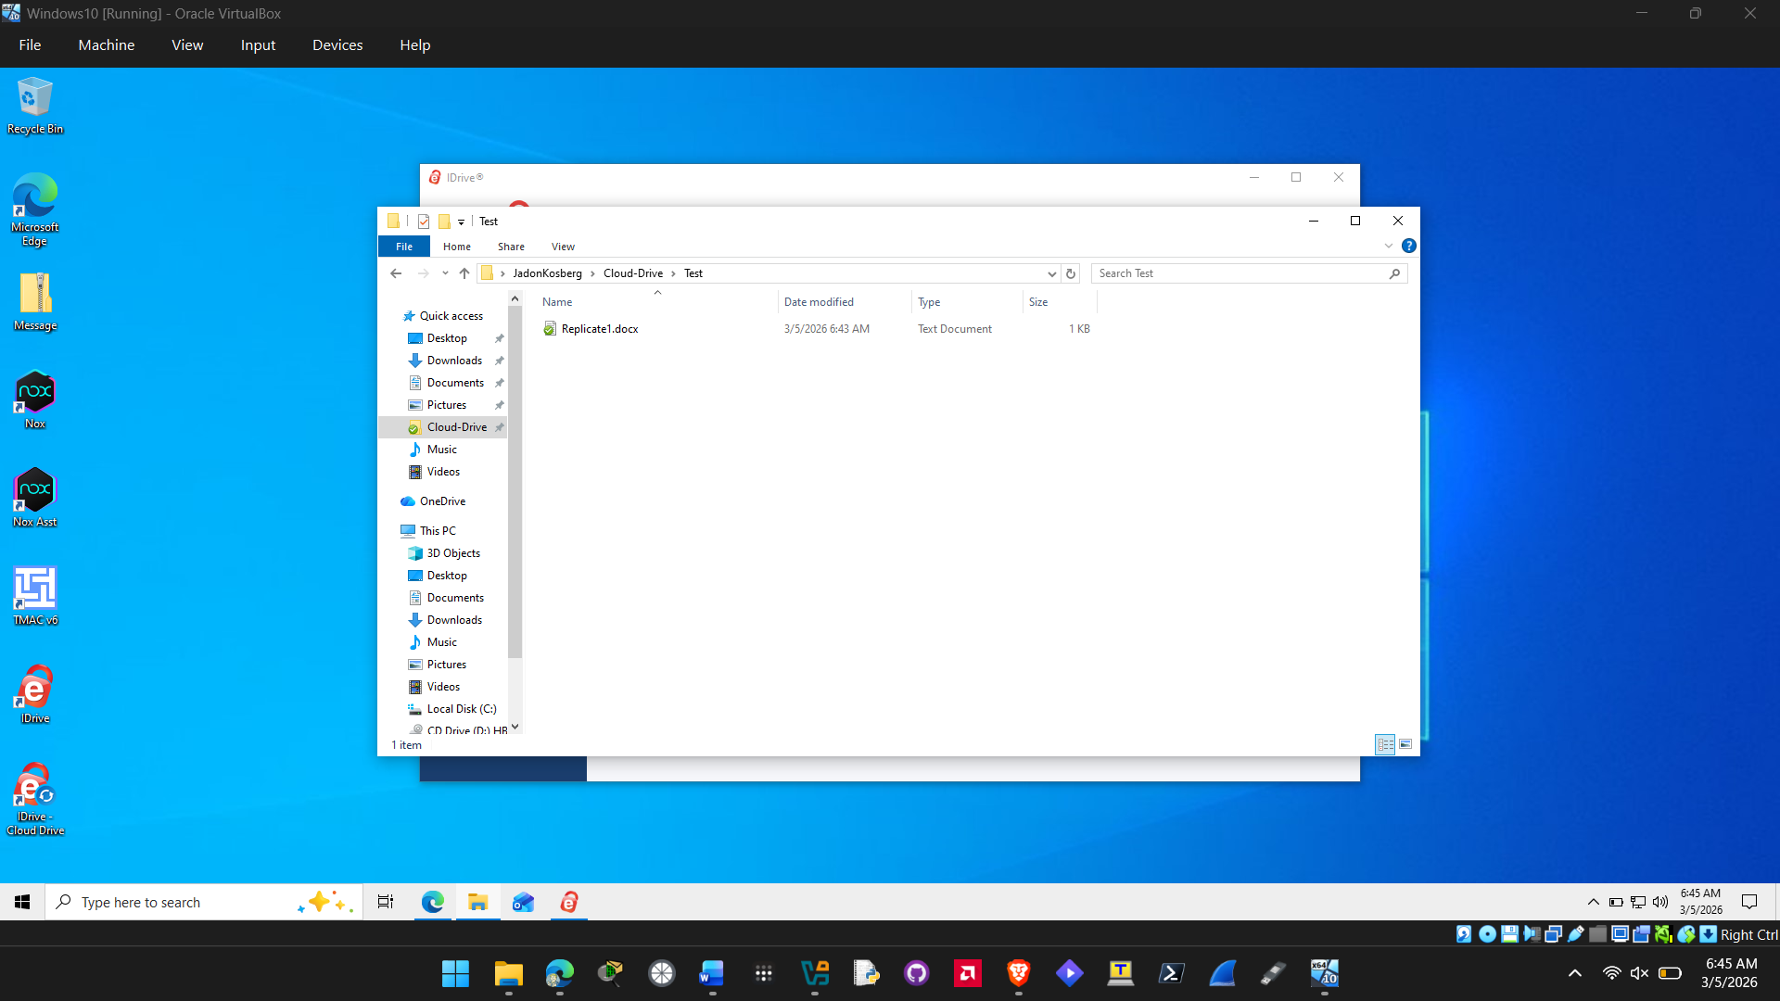
- Click Backup in the left pane.
- Click Change.
- Browse through the computer folders that you designated to be copied to iDrive. Locate the Test folder and note that it now is included as a folder to be copied. Any subfolder that is created under a folder designated to be copied will automatically be included in future copies unless it is unchecked here. Click Cancel.
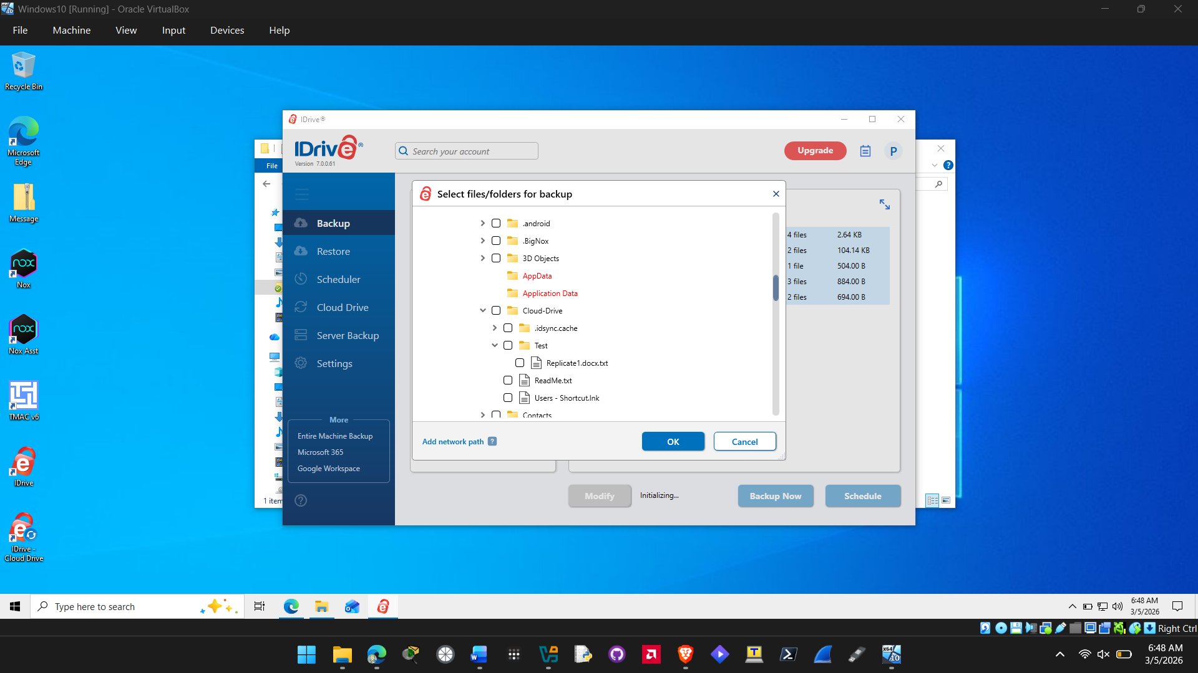
- Immediate replication is turned on by default so that any file that is changed will be immediately copied to iDrive. Click Settings in the left pane.
- Under General Settings, note that Continuous Data Protection is on and the Frequency is set to Real-time.

Caution: Although several cloud data copy solutions advertise real-time continuous data protection, research has shown that these products take 15 minutes or longer to copy any changes to the cloud. iDrive is one of the few products that performs actual real-time updates.

- If immediate (real-time) continuous data protection is not necessary, it can be changed to a lower time interval. Turn off Continuous Data Protection.
- Click the down arrow next to Frequency. Note the options that are less than real-time protection. When would you choose one of these options instead of real-time protection?
- You might want the time interval setting changed to a lower time interval if you know the data being backed up is not being changed that often so theres no need ot have real time updates on that data.

- Turn on Continuous Data Protection. Click Save Settings.
- Navigate to the file Replicate1.docx on your computer using File Explorer.
- Change the filename from Replication1.docx to Replication2.docx.

- Click Backup in the left pane.
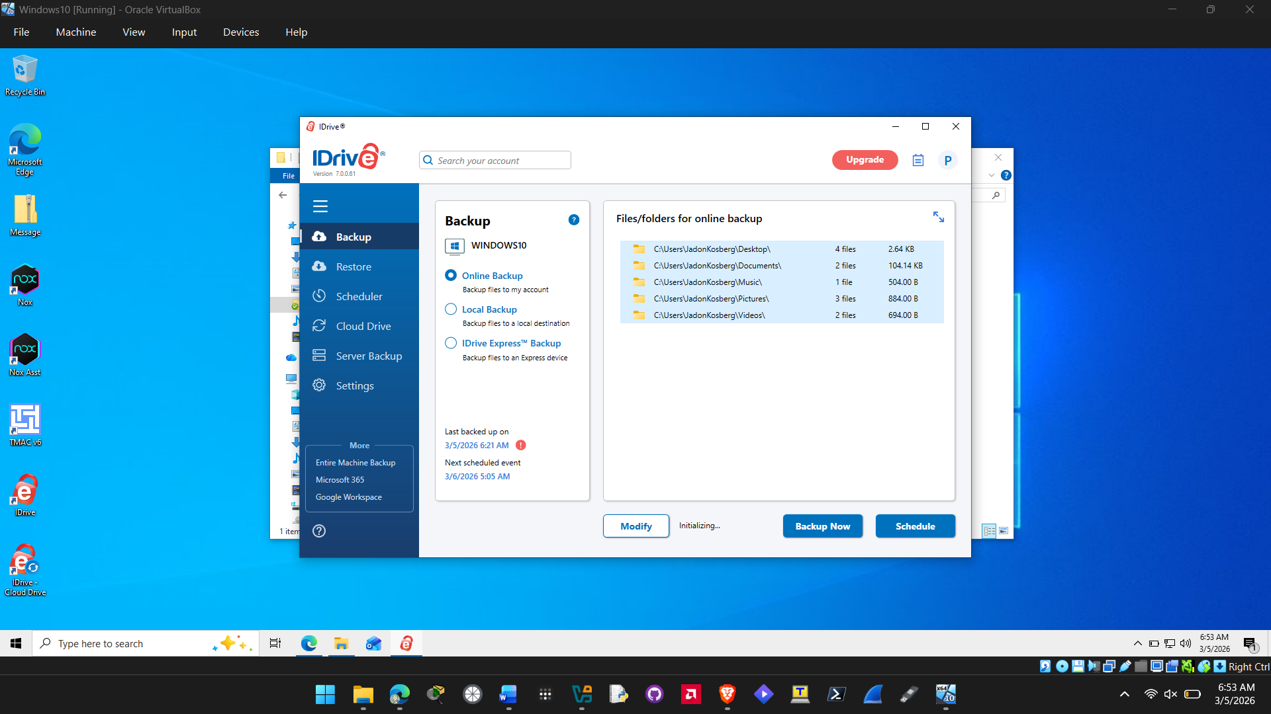

- Click Change.
- Navigate to the Test folder and locate the file stored in that folder. How quickly did iCloud change Replication1.docx to Replication2.docx?
It was changed instantly from 1 to 2.

- How flexible is iDrive for users? Would you recommend it?
iDrive is very flexible for users you can create backups and restores of your data as well as scheduled times and notifications for when your data is being backed up. I would recommend it only if you are looking for a third party tool to back up your data or if you are wanting some sort of cloud storage service.

- Close all windows.

Criteria | Meets Requirements | Needs Improvement | Incomplete
Content | The assignment clearly and comprehensively addresses all questions in the assignment.  15 points | The assignment partially addresses some or all questions in the assignment.  8 points | The assignment does not address the questions in the assignment.  0 points
Organization and Clarity | The assignment presents ideas in a clear manner and with strong organizational structure. The assignment includes appropriate content, coverage of facts, arguments, and conclusions.  10 points | The assignment presents ideas in a mostly clear manner and with some organizational structure. The assignment includes appropriate content, coverage of facts, arguments, and conclusions.  7 points | The assignment does not present ideas in a clear manner or with a strong organizational structure. The assignment includes some appropriate content, but coverage of facts, arguments, and conclusions are not logically related and consistent.  0 points
Research | The assignment is based upon appropriate and adequate data collection and analysis of results from the activity or research from academically reliable sources.  5 points | The assignment is based upon adequate data collection and includes some analysis of results from the activity or research from academically reliable sources.  3 points | The assignment is not based upon appropriate data collection and includes no analysis of results from the activity or research from academically reliable sources.  0 points
Grammar and Spelling | The assignment has two or fewer grammatical and spelling errors.  5 points | The assignment has three to five grammatical and spelling errors.  3 points | The assignment has more than five grammatical and spelling errors, is incomplete, or is unintelligible.  0 points

